Classification of Sentiment Towards BPJS Services Using the C50 Algorithm

Amellia Fahezha Cahyaningrum^{1*}, Yulison Herry Chrisnanto ², Ade Kania Ningsih³

¹Department of Informatics Engineering/Faculty of Science and Informatics/Universitas Jenderal Achmad Yani, Cimahi, Jawa Barat, Indonesia
² Department of Informatics Engineering/Faculty of Science and Informatics/Universitas Jenderal Achmad Yani, Cimahi, Jawa Barat, Indonesia
³ Department of Informatics Engineering/Faculty of Science and Informatics/Universitas Jenderal Achmad Yani, Cimahi, Jawa Barat, Indonesia

*Email: email@email.com

ARTICLE INFO | ABSTRACT
Keywords:  text mining, sentiment classification,  health BPJS,  c50 algorithm | This public health insurance program for all Indonesian people is supervised by the Social Security Administering Body (BPJS) for Health, an Air-Owned Enterprise. Thus, it will be easier for the public to find information about what policies the government has implemented to regulate BPJS. One of them is that people can find information on the social network Twitter. Due to its ease and simplicity of use, the number of tweets can easily grow quickly, which is why Twitter is more popular among Indonesians for communicating. Twitter is widely used as a promotional medium as well as a means of expressing opinions regarding criticism, suggestions, issues, and opinions of a public nature such as the views of netizens on new government policies and so on. One of them is in BPJS services, the large number of BPJS users causes BPJS to provide feedback services to users to find out how many good and bad responses to BPJS services. Sentiment classification is a branch of text mining. Sentiment classification is very basic in the evaluation process of a topic problem. Then the sentiment classification has the main objective of finding out the polarity of positive, and negative sentiment. The c50 algorithm method is one of the methods that can be used in the classification of BPJS service sentiment. In this research, the classification of BPJS service sentiment through Twitter media was carried out using the C50 algorithm method.

INTRODUCTION
BPJS (Social Security Administering Body) Health is a national health insurance program in Indonesia that aims to provide affordable health services for the entire community. As a large public service, BPJS Health receives various reviews and opinions from the public regarding the quality of its services. Health services include efforts made individually or collectively in certain relationships to develop government assistance, prevent disease, and improve the healing process (Mega et al., 2020). This research aims to determine public sentiment by combining positive and negative responses to BPJS services (Similarity, 2022). In this case, sentiment classification is a way to find out a person's or group's assessment of a certain subject, topic, opinion, or opinion in data mining. Classification is one of the most important steps in grouping new data or objects into categories or labels based on certain attributes (Dan et al., 2021).
This research uses the C5.0 Algorithm method. According to Revathy & Lawrence (2019), the C5.0 Algorithm can handle large-scale data well and provides higher accuracy compared to the C4.5 algorithm (Bidang et al., n.d.). In addition, the performance of the C5.0 algorithm is faster and uses memory more efficiently, resulting in a smaller decision tree than the C4.5 algorithm (Limbong et al., 2022; Amalda et al., 2022). The rules in the C5.0 algorithm also have a lower error rate for invisible cases and a high accuracy value compared to other C4.5 algorithms. In addition, this algorithm can automatically remove useless attributes in the analysis of the data as it is a feature of today's modern techniques to help improve the performance of predictive models significantly (Technology & Science, 2022). The C5.0 algorithm has several weaknesses, including being sensitive to unbalanced or proportional data which can cause the model to tend to predict the majority class and ignore the minority class. In addition, this algorithm is not effective for handling high-dimensional data and cannot handle unstructured data such as text or image data. The C5.0 algorithm is also susceptible to overfitting if the model is too complex and fits well on the training data so it is difficult to generalize to new testing data. Therefore, it is necessary to set the right parameters so that the results are optimal in predictive modeling using the C5.0 algorithm on certain specific datasets (Matematika, 2022). One of the classification algorithms commonly used in data mining strategies is C50. In previous research by Ridawati Manik, Pristiwanto, and Kennedi Tampubolon entitled 'Credit Collection Forecasting Using the C5.0 Algorithm', it was stated that the C5.0 algorithm can be applied well to identify problems and see the relationship between the factors that contribute to the problem (Zamasi, 2021).
The classification stages consist of model creation, model application, and evaluation. In developing the model, training data is used which already has attributes, classes, and labels. Classification is a type of learning that aims to find relationships between input and target attributes (Westley et al., 2022). The data from this classification provides an overview of the current sentiment of the BPJS user community. This research aims to evaluate the effectiveness of the C50 algorithm, measuring the extent to which the C50 classification algorithm is effective in classifying customer sentiment towards services provided by the Social Security Administering Body (BPJS). Then identify the ability of the C50 algorithm to recognize and classify positive or negative sentiments expressed by customers regarding BPJS services (Law et al., 2019). Then identify influential service aspects. To identify the attributes or aspects of BPJS services that most influence positive and negative customer sentiment. Specific recommendations will be prepared based on sentiment analysis of customer feedback, which is expected to help BPJS respond with more appropriate solutions (Hari et al., n.d.). By providing in-depth insight through sentiment classification results, this research is expected to help BPJS understand customer perceptions and design improvement strategies based on the feedback received.

METHOD
Current System Analysis
With the help of ongoing system analysis, the problem of disassembling a complete and real system into computer parts or components is solved to identify and evaluate the problems caused by the system, thereby leading to solutions for improvement and development in a better direction that meets technological development needs. The system that will be developed in this research does not yet have a working system because it is a new system whose data is collected via the Kaggle website and processed through the C5.0 classification algorithm and TF-IDF weighting, where the results can be used to identify sentiment.

Analysis of the BPJS Service Sentiment Classification System
System analysis is a process for evaluating and analyzing classification systems, this analysis process consists of a data collection process (selection), then a preprocessing process is carried out, which is a stage to eliminate noisy and missing values by using features such as cleaning, case folding, tokenizing, filtering, steaming. Then carry out the data transformation process using TF-IDF as a weighting for the terms. The data mining process is the application of the c5.0 algorithm such as determining root and node as initial determinants for decision trees. The last one is the validation test process or measuring the performance of the model that has been implemented.

RESULTS AND DISCUSSION
System Implementation
Software implementation of the BPJS service sentiment classification system that has been designed by UML. This software was built using the Javascript programming language and MongoDB as the database (Syuhada et al., 2021).
Interface Implementation
The interface implementation displays dashboard pages, data management, preprocessing, sentiment classification, and results.
Dashboard Implementation
The dashboard page interface is the initial display for entering the system. There are several buttons in the system. The implementation of the Dashboard page can be seen in Figure 1.
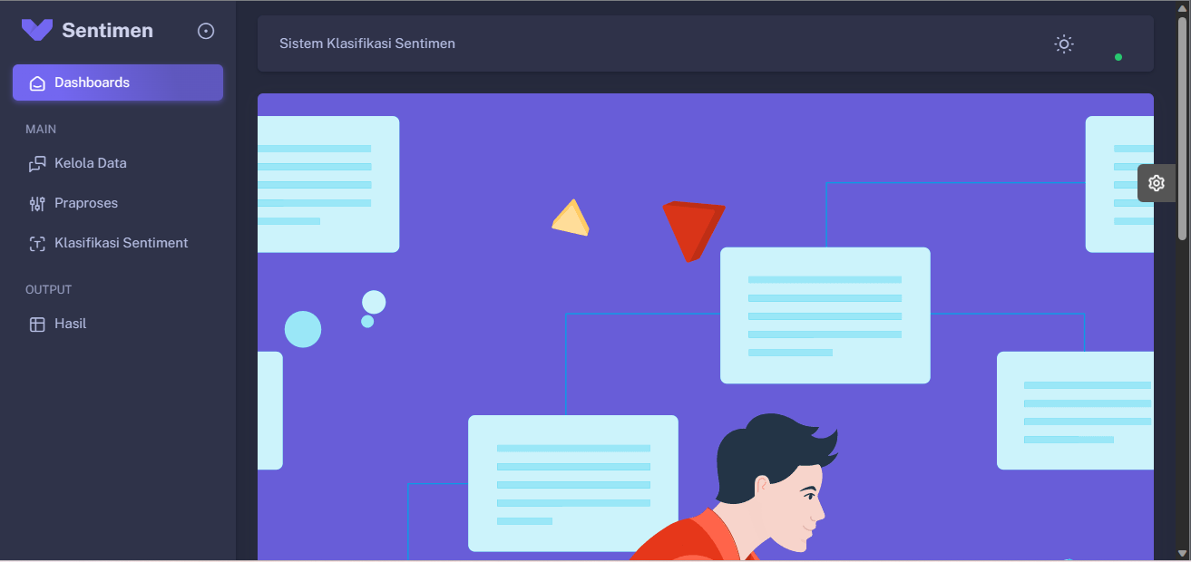
Figure 1. Dashboard Implementation

Implementation of Data Management
The data management page interface is a display that shows the data. The implementation of the Dashboard page can be seen in Figure 2.

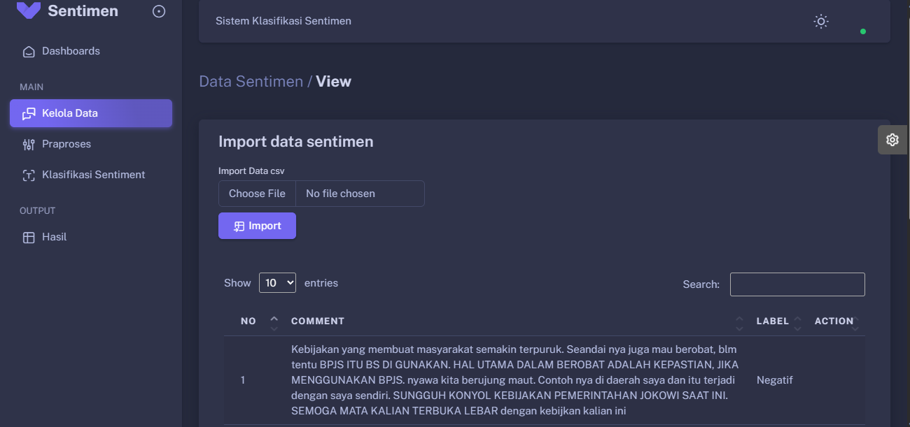
Figure 2. Implementation of the data management page

Implementation of Data Preprocessing
The preprocess data page interface is a display on the system used to retrieve sentiment data from the database and then display it (Zamasi, 2021). The implementation of the data preprocessing page can be seen in Figure 3.

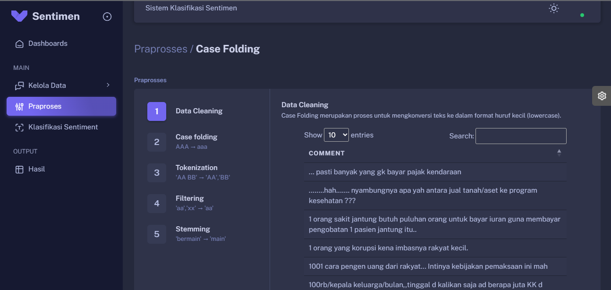
Figure 3. Implementation of data preprocessing

Implementation of sentiment classification
The sentiment classification interface is a display of the system used to retrieve data and then classify it. The implementation of the sentiment classification page can be seen in Figure 4.

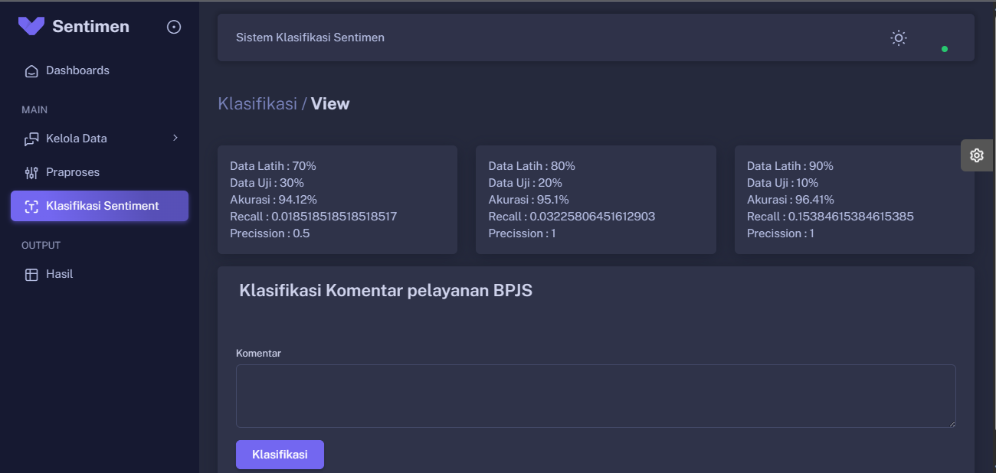
Figure 4. Implementation of sentiment classification

Implementation of Results
Implementation of results is built based on the final results that have been implemented in the program (Purba et al., 2022). Implementation results can be seen in Figure 5.

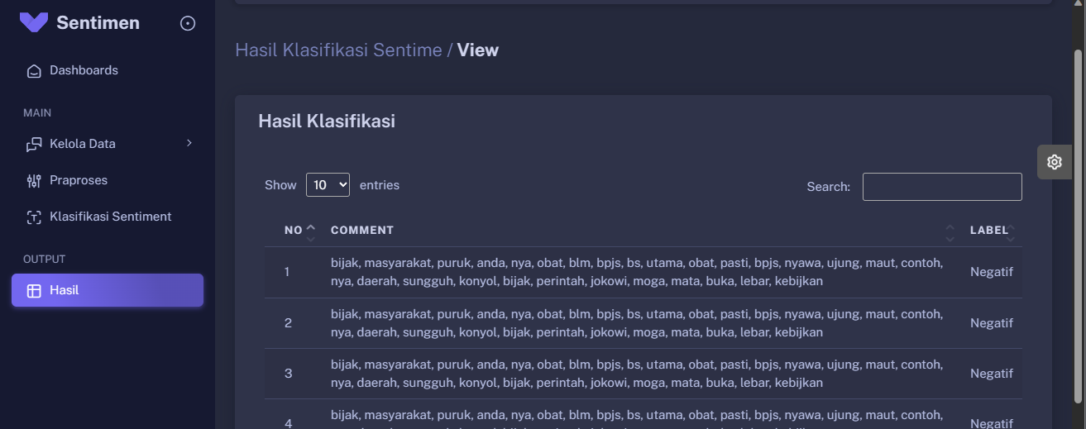
Figure 5. implementation results

Database Implementation
The database implementation is built based on the database design that was created previously. A database is needed for implementation using MongoDB software, the following is a table in the database which can be seen in Figure 6.

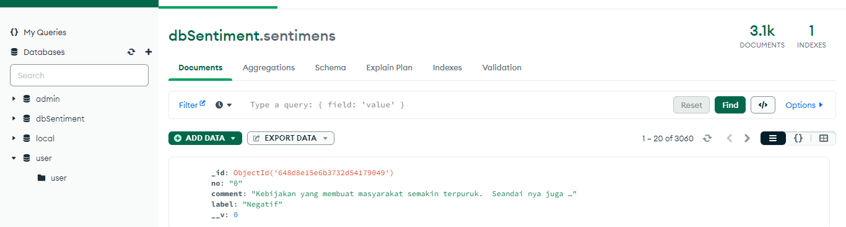
Figure 6. Database implementation

Confusion Matrix Calculation
In this research, the model evaluation process was carried out using Confusion Matrix Technology to achieve the accuracy obtained using the model in data mining. Accuracy is used in the accuracy identification process. If the indicators to be calculated about achieving accuracy are:
- True Positive (TP) is the total positive cases included in the correct classification.
- True Negative (TN) total negative cases included in the true classification.
- False Positive (FN) total positive cases included in the wrong classification.
- False Negative (FN) is the total number of negative cases included in the wrong classification.

Calculating the Confusion Matrix
The following is a way to calculate the confusion matrix, available in the following image:

- Calculating Confusion Matrix training/data test (80/20)

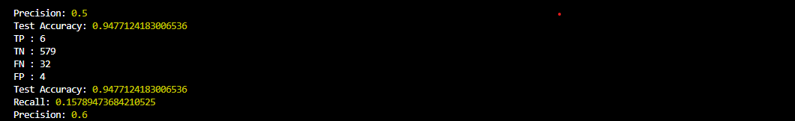
Figure 7 Confusion matrix 80/20

- Calculating Accuracy = (TP+TN) / (TP+TN+FP+FN)
Accuracy = ( 6+579) / (6+579+4+32)
= 0.942 x 100%
= 950%
- Calculating Precision = TP / ( TP + FP)
Precision = 6 / ( 6 + 4)
= 0.6 x 100%
= 0.6%
- Calculating Recall = TP / (TP + FN)
Recall = 6 / ( 6 + 32 )
= 0.157 x 100%
= 155.2%

Based on the results of accuracy testing using the system confusion matrix, it can be concluded that the BPJS service sentiment classification system uses the C5.0 algorithm to produce accuracy, precision, and recall (80/20) providing 0.6% precision, 0.6% precision, and 155% recall. .2%, 950% accuracy

Software Testing
System testing is a method used to test the quality of the system. This research uses the black box testing method.
Test Method
Testing using black box testing techniques focuses on the functional requirements of the software and allows system analysis to obtain a set of input conditions that are carried out by the functional program (Sungkar & Qurohman, 2021). The black box testing method aims to find the cause if it occurs in:
- Determine quality testing objectives.
- Determine the category of quality test results
- Designing quality tests based on use case groupings
- Implementation of quality testing
- Conclusions and quality testing results
- Test objectives
The purpose of quality testing of the system being built can be seen in Table 1.

Table 1. Testing Objectives
No | Use case | Purpose
1 | Manage data | Test the software's ability to upload review sentiment data and then store it in a database and test the ability to view review sentiment data
2 | Dashboard | Test the software's ability to display the program's start menu
3 | Preprocessing | Testing the software's ability to process sentiment data with case folding, tokenizing, stopword removal, and steaming
4 | Sentiment classification | Testing the software's ability to calculate and classify sentiment data using TF-IDF, C50 algorithm, and Cosine similarity
5 | Results | Test the software's ability to produce results and perform accurate calculations using a confusion matrix

Quality Test Result Categories
In determining the category in quality testing, it is divided into 2 categories, namely:
- Appropriate
If the quality and function of the software being tested are to its planning and usability objectives, then it is included in the successful category.
- Not suitable
If the quality and function of the software being tested do not match its planning and usability objectives, then it is included in the failed category.

Quality Testing Scenarios
Software testing scenarios are designed to look for errors in the system, thereby creating quality testing scenarios with incorrect and correct steps or stages of system use. The quality testing scenario can be seen in Table 2.
Table 2. Quality Testing Scenarios
Use case | Function name | Test code | Test case
Dashboard | Dashboard | KU.101 | Tests software capabilities when the user displays the home page
Manage data | Manage data | KU.102 | Test software capabilities when users upload data and display data
Preprocessing | Preprocessing | KU.103 | Testing software capabilities when users process sentiment data with case folding, tokenizing, stopword removal, and steaming
Sentiment classification | Sentiment classification | KU.104 | Testing software capabilities when the user calculates and classifies sentiment data with TF-IDF, C50 algorithm, and Cosine similarity
Results | Results | KU.105 | Test the software's capabilities when the user displays the results and performs accuracy calculations using a confusion matrix
Dashboard | Dashboard | KU.101 | Tests software capabilities when the user displays the home page

Software Testing
Testing is carried out to compare the suitability of the system being built with the system being designed to produce test results that are suitable and non-compliant. Software testing can be seen in Table 3.

Table 3. Software Testing
No | Test case | Expected output | Results obtained
1 | Dashboard | Users can open the home page | Displays the home page
2 | Manage data | Users can upload data and view data in the system | Save uploaded data and display stored data
3 | Preprocessing | The system processes data by case folding, tokenizing, stopword removal, and steaming. | Storing results in the database
4 | Sentiment classification | Carry out the process of displaying the results | Display the calculation results and then save them to the database
5 | Results | Displays results and accuracy tests with the c50 algorithm and confusion matrix | Displays accuracy tests for training and test data with c50 using the confusion matrix

Furthermore, the conclusion of the black box testing that has been carried out is in a table with a total of 5 functions, namely, dashboard, data management, preprocessing, classification as well as results and validation. then it can be calculated the number of functional suitability presentations in the following system (Sudarma, 2018):

Number of test codes = 5 codes
Test code with appropriate results = 5 codes
Test code with inappropriate results = 0 codes
Percentage
$$percentage \frac{(number of test codes-non-matching test codes)}{number of test codes} x 100\%$$
= $\frac{( 5-0)}{5} x 100\%$
= 100%

CONCLUSION
The C5.0 classification algorithm has made a significant contribution to overcoming the challenges of sentiment analysis for services provided by the Social Security Administering Body (BPJS). Through the implementation of the C5.0 algorithm, this research succeeded in measuring and classifying customer sentiment towards BPJS services with satisfactory accuracy. The results of the analysis using the C5.0 algorithm can identify specific aspects that influence positive and negative customer sentiment towards BPJS services. These attributes, such as officer professionalism, response time, facility accessibility, and claims procedures, can be better identified through the C5.0 algorithm approach. Apart from that, this research can provide concrete recommendations for BPJS to improve service quality based on the results of the sentiment analysis obtained. These recommendations are generated by identifying areas that require improvement or improvements. Thus, the C5.0 algorithm provides valuable guidance in responding to customer feedback with more accurate solutions. However, the implementation of the C5.0 algorithm is not without challenges, such as the complexity of data preprocessing, handling minority classes, and setting algorithm parameters. This research provides insight into how to overcome these obstacles through a careful approach and selection of appropriate methods.

REFERENCES
Amalda, R. N., Millah, N., & Fitria, I. (2022). Implementasi algoritma c5.0 dalam menganalisa kelayakan penerima keringanan ukt mahasiswa itk. 7(1), 101–116.
Bidang, P., Sains, K., Mardi, Y., Gajah, J., No, M., & Barat, S. (n.d.). Jurnal Edik Informatika Data Mining : Klasifikasi Menggunakan Algoritma C4 . 5 Data mining merupakan bagian dari tahapan proses Knowledge Discovery in Database ( KDD ) . Jurnal Edik Informatika.
Dan, P., Tni, K., & Rsal, D. I. (2021). Landosar Parsaulian. Analisis Pelayanan BPJS Bagi… | 596. 596–604.
Hari, E., Prastyo, A., Studi, P., Teknik, S., Informasi, F. T., Hasyim, U., Studi, P., Teknik, S., Informasi, F. T., Hasyim, U., Informasi, P. S. S., Informasi, F. T., & Hasyim, U. (n.d.). Implementasi Teknik Web Scraping Pada Situs Berita Menggunakan Metode Supervised learning Implementasi Web Scraping Pada Situs Berita Menggunakan Metode Supervised learning IGL Putra Eka Prismana Radityo Wiratsongko Implementasi Teknik Web Scraping Pada Situs Berita Menggunakan Metode Supervised learning.
Law, A., Hukum, F., Diponegoro, U., Services, P., Publik, P., & Pendahuluan, A. (2019). Badan Penyelenggara Jaminan Sosial ( BPJS ) Kesehatan Sebagai Pelayanan Publik. 2(4), 686–696.
Limbong, J. J. A., Sembiring, I., Hartomo, K. D., Kristen, U., Wacana, S., & Korespondensi, P. (2022). Analysis Klasifikasi Sentimen Ulasan Pada E-Commerce Shopee Berbasis Word Cloud Dengan Metode Naive Bayes Dan K-Nearest Analysis Of Review Sentiment Classification On E-Commerce Shopee Word Cloud Based With Naïve Bayes And K-Nearest Neighbor Methods. 9(2), 347–356. https://doi.org/10.25126/jtiik.202294960
Matematika, J. I. (2022). Digital Digital Repository Repository Universitas Universitas Jember Jember Digital Digital Repository Repository Universitas Universitas Jember Jember.
Mega, P., Dharmapatni, N., Luh, N., & Merawati, P. (2020). Jurnal Bumigora Information Technology ( BITe ) Penerapan Algoritma Support Vector Machine Dalam Sentimen Analisis Terkait Kenaikan Tarif BPJS Kesehatan Jurnal Bumigora Information Technology ( BITe ) Jurnal Bumigora Information Technology ( BITe ) Jurnal Bumigora Information Technology ( BITe ). 2(2), 105–112. https://doi.org/10.30812/bite.v2i2.904
Purba, W., Caprio, C. Di, Ryan, M., & Program, S. (2022). Machine Translated by Google. 10(2), 1050–1054.
Similarity, C. (2022). Temu Kembali Informasi Berita Kegiatan Program Studi Menggunakan Algoritma Pembobotan TF-IDF Dan Cosine Similarity. September, 10–11.
Sudarma, I. M. (2018). Implementasi Algoritma C5 . 0 pada Penilaian. 17(3), 1–6.
Sungkar, M. S., & Qurohman, M. T. (2021). Penerapan Algoritma C5 . 0 Untuk Prediksi Kelulusan Pembelajaran Mahasiswa Pada Matakuliah Arsitektur Sistem Komputer. 5, 1166–1172. https://doi.org/10.30865/mib.v5i3.3116
Syuhada, A. S., Simanullang, A. M., Lewa, D. S., & Marthin, S. J. (2021). Fakultas teknik universitas maritim raja ali haji 2021.
Technology, I., & Science, C. (2022). No Title. 5.
Westley, V., Thomas, D., & Rumaisa, F. (2022). Analisis Sentimen Ulasan Hotel Bahasa Indonesia Menggunakan Support Vector Machine dan TF-IDF. 6, 1767–1774. https://doi.org/10.30865/mib.v6i3.4218
Zamasi, N. (2021). Implementasi Algoritma C 5 . 0 Pada Analisa Data Potensi Pertanian dan Perternakan. 2(4), 184–190.

